**Moulik Tammana**

**Q1. Using Packet Tracer, simulate an ARP spoofing attack. Analyze the behavior of devices on the network when they receive a malicious ARP response.**

**We have configured the network in this format:**

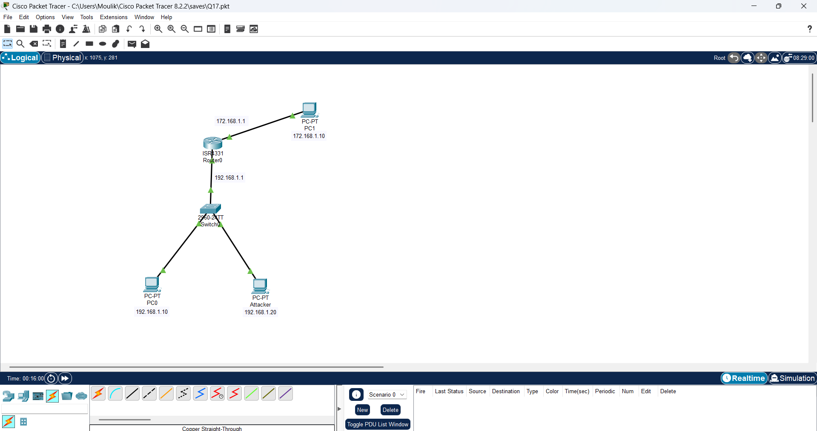

**Before changing the MAC address of the attacker, we were able to ping PC1 to PC0 and ping PC1 to the Attacker**

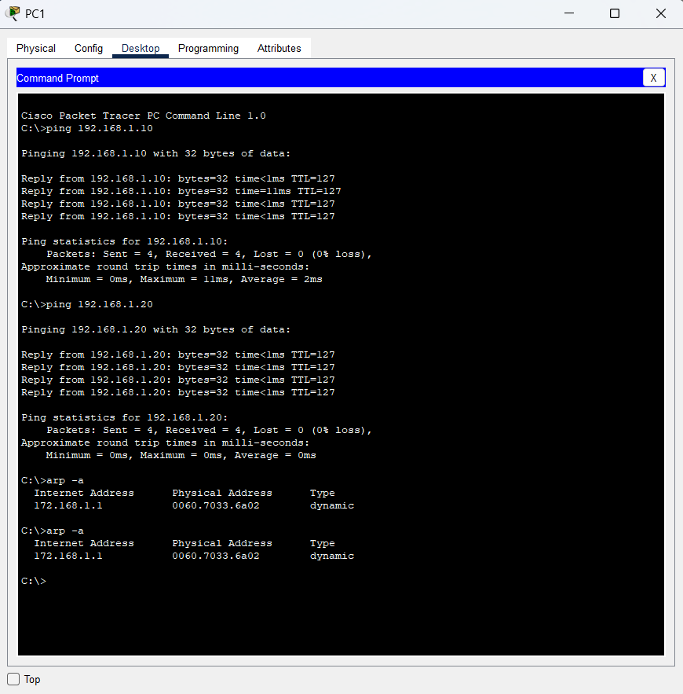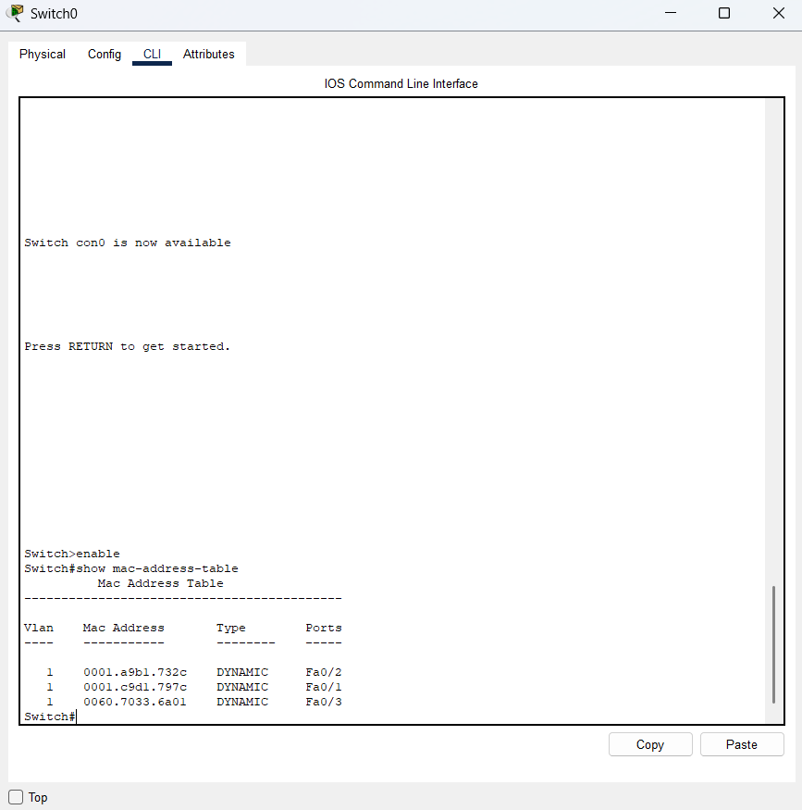

**Assigned the same MAC address to both PC0 and Attacker**

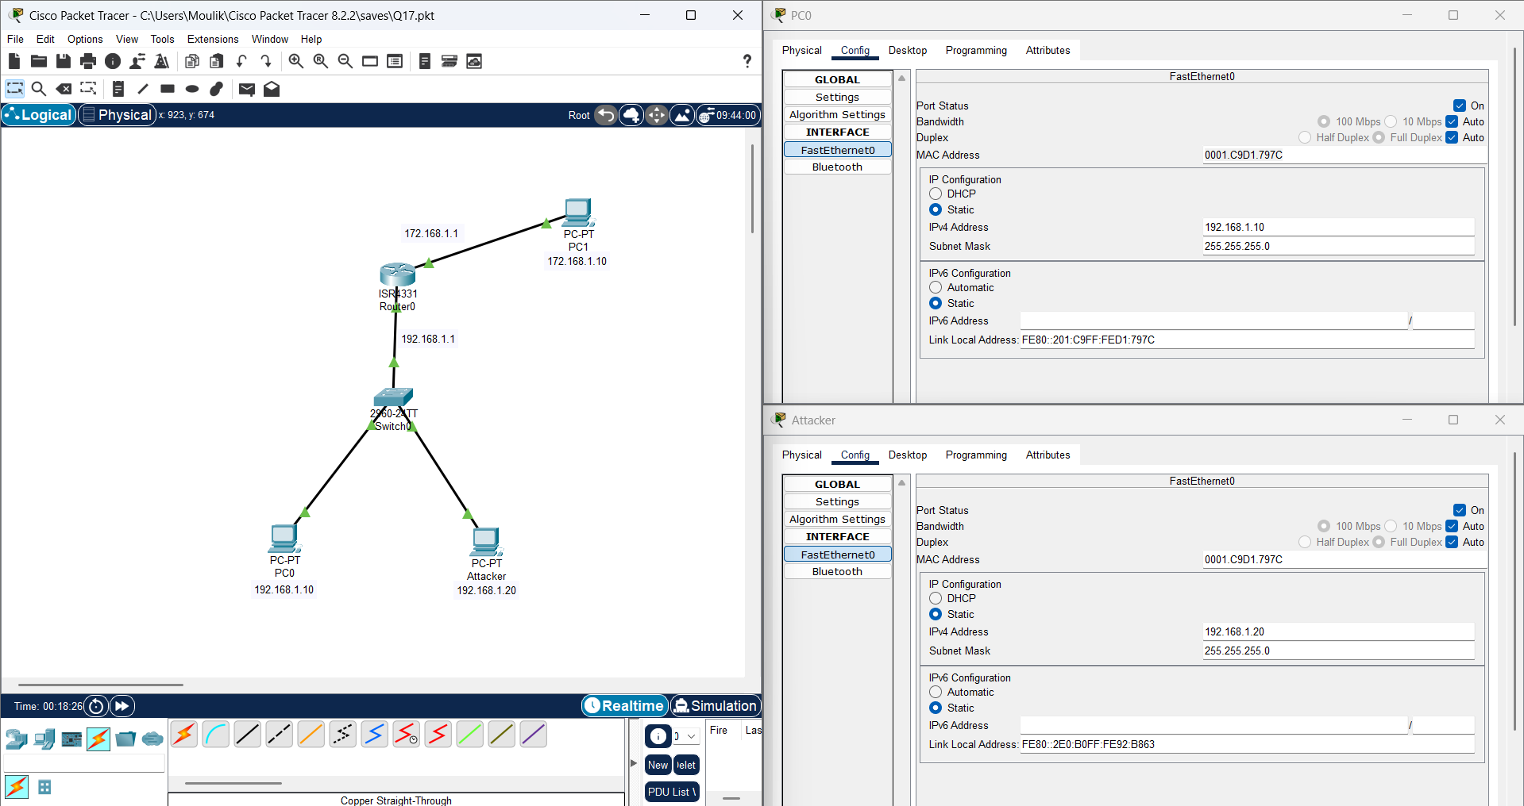

**The packet is routed to the attacker even when we try to ping from PC1 to PC0.**

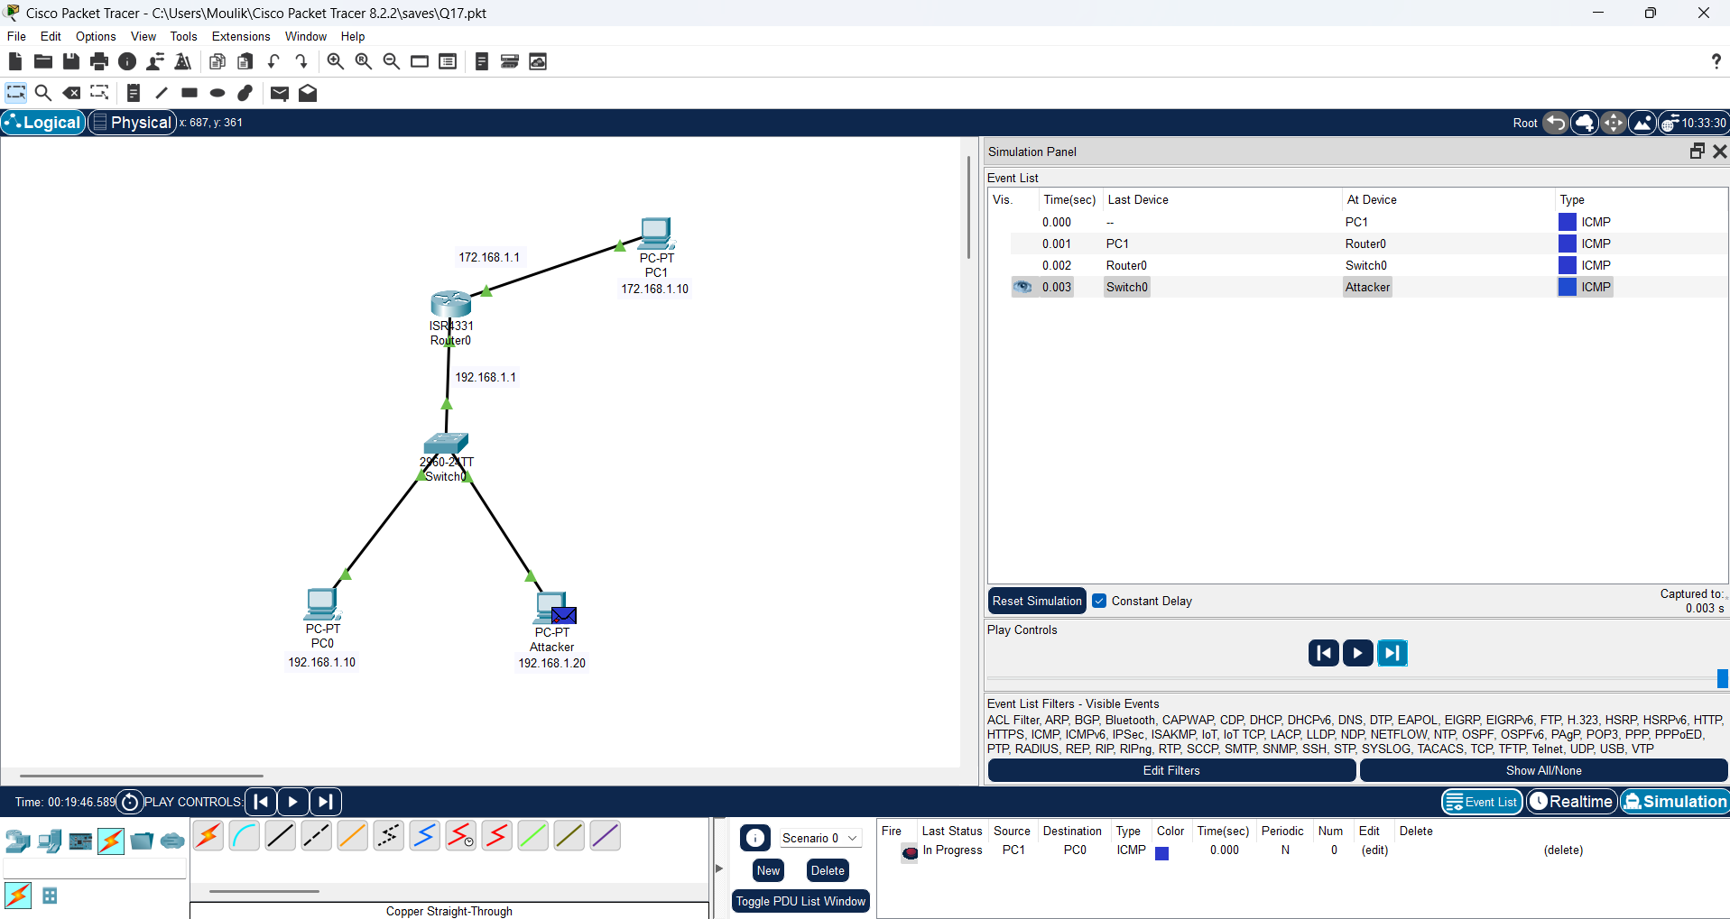

**We get a request timed out as this is a ark attack.**

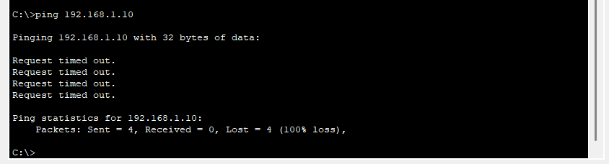

**But the destination of the packet is assigned to 192.168.1.10 but due to arp spoofing, the packet is routed the attacker.**

